|  |  |  |
| --- | --- | --- |
| Write an application in C++ to read a file name as command line argument and to process and extract the user, host and domain names.Perform the specified operations: | | |
| Requirement Tag | Requirement Description | Comments |
| FSTR/01 | Open file, read each line containing email id and display. Handle errors if any. |  |
| FSTR/02 | Extract username, host and domain name from all valid email id’s . (Consider only domain names as .com or .edu as valid domains) | Hint:  1. For invalid domain names or for missing fields, display error message accordingly and ignore entry.  2. For valid entry, use a structure or class with username, host and domain name members. Create an object and initialize with extracted email detail. |
| FSTR/03 | Display valid email id’s |  |

**CPP_7b_Assignment**

FSTR/01 Open file, read each line containing email id and display. Handle errors if any.

Ans:

First create a file with content to read data : rajanaladurgadevi@gmail.com

[durgadevirajanala@gmail.com](mailto:durgadevirajanala@gmail.com)

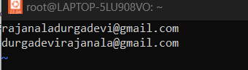

**Vi read.cpp:**

**#include<iostream>**

**#include<fstream>**

**#include<vector>**

**using namespace std;**

**int main()**

**{ string str;**

**ifstream file("open.txt");**

**while(getline(file,str)){**

**cout<<str<<endl;**

**}**

**file.close();**

**}**

**~**

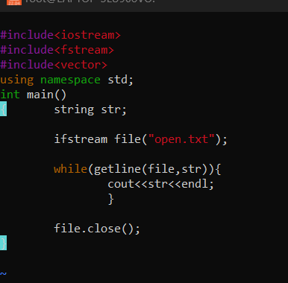

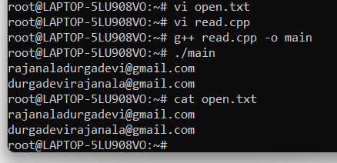

FSTR/02 Extract username, host and domain name from all valid email id’s . (Consider only domain names as .com or .edu as valid domains)

FSTR/03 Display valid email id’s

Ans:

